JENKINS Tutorial

Download Jenkins for website and make a copy in your local machine.
Then you can see the path like below
- D:\Program Files\Jenkins : within this path you will be able to see file like Jenkins.war, so you need to start the Jenkins server, it will have default path 8080.
- Still like following commands : D:\Program Files\Jenkins>java -jar jenkins.war
- Then you can login to the Jenkins URL like below :
- 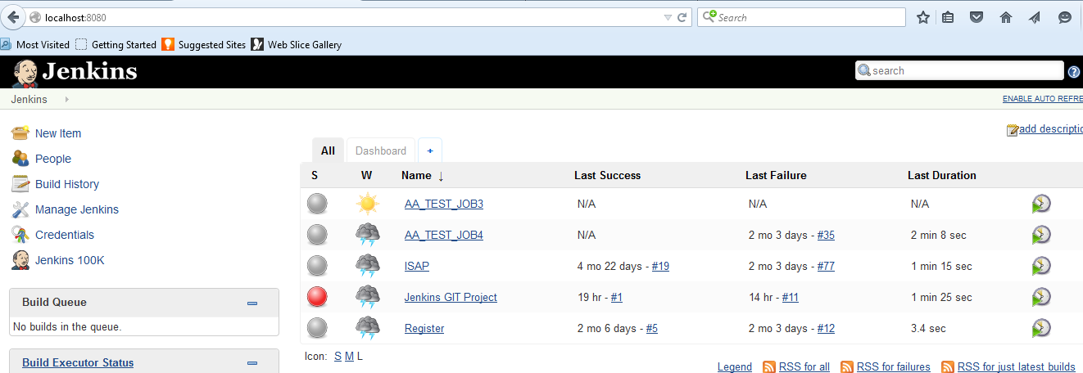
- Manage Jenkins :
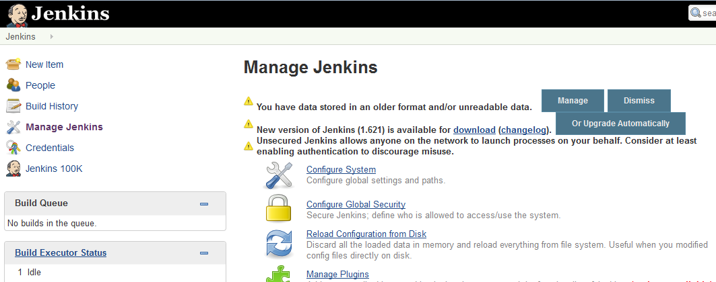
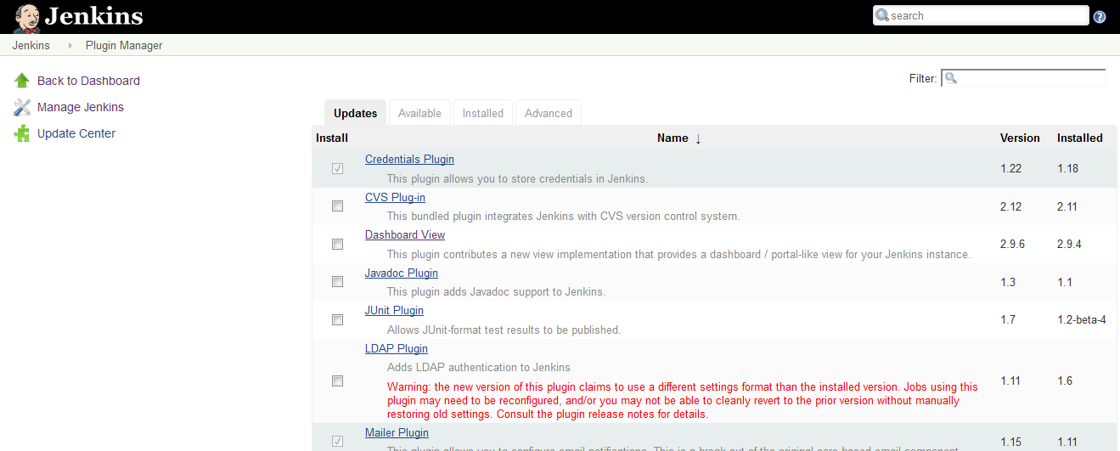

- In that you can see all the plugins installed in the Jenkins in the installed tab, in the available tab you can search if you need to install any new plugins to your Jenkins.
- 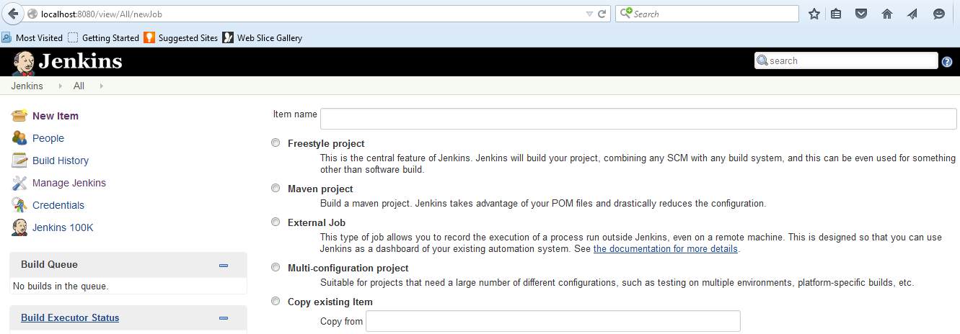
- You can create a job using New Item , ethier freestyle or maven project.
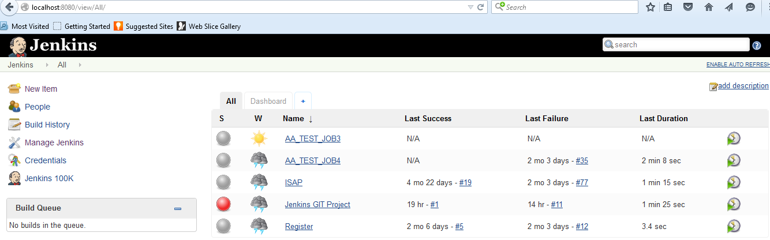

- Above you can see list of jobs created and once it is created you have to configure all the details like below.
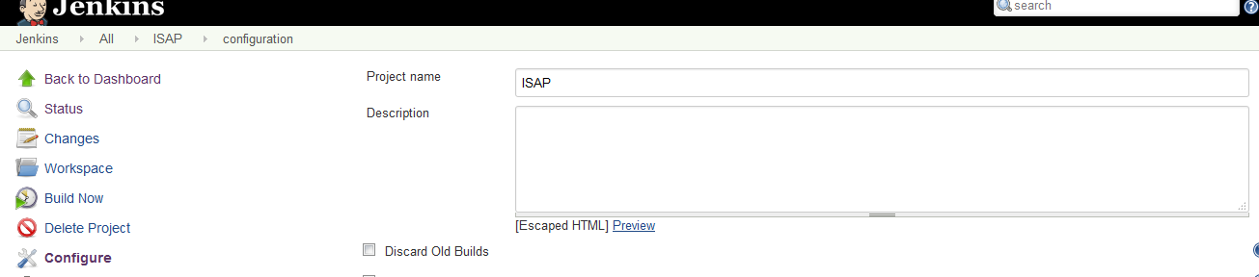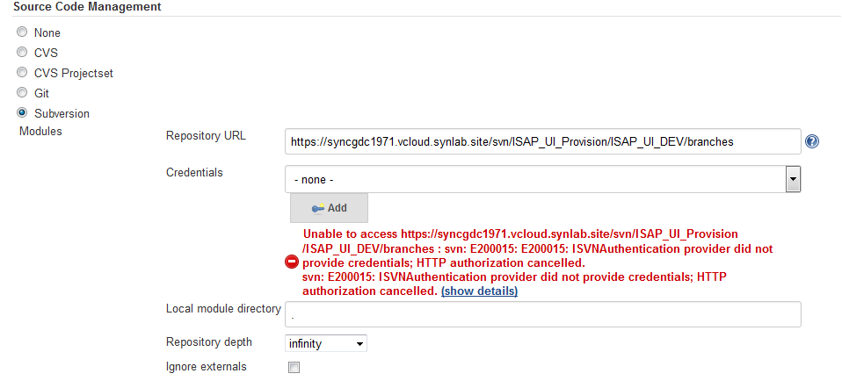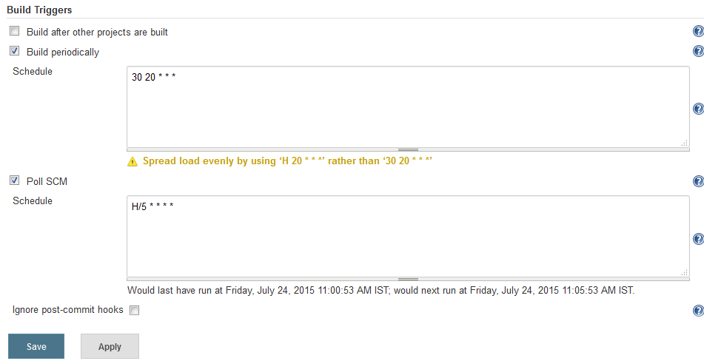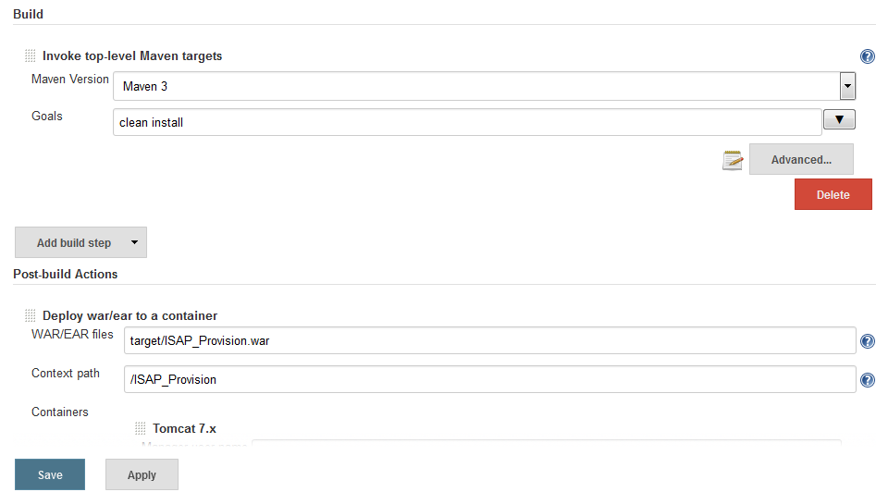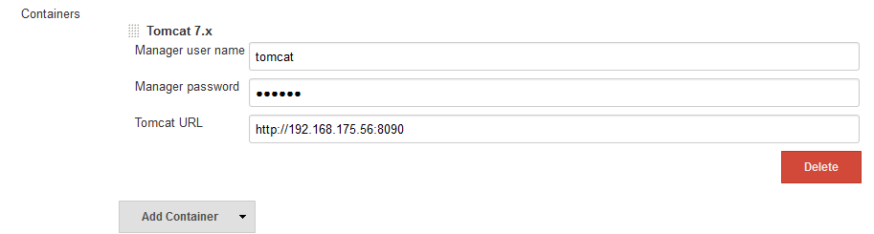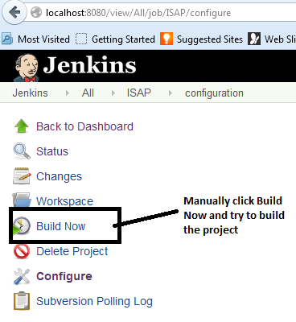

Dashboard plugins need to be installed in plugins , once you installed dashboard plugins you need to create a Dashboard project using New Item,

Dashboard – It will show all the list details of build history , build summary , Build statistics , Test statatics chart.
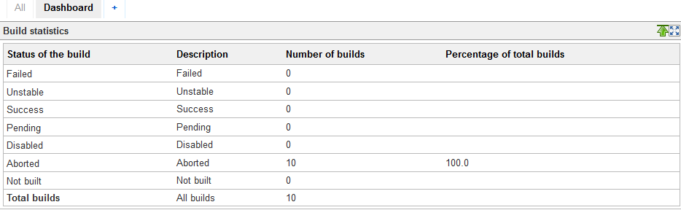
PMD plugins - shows the code review picture
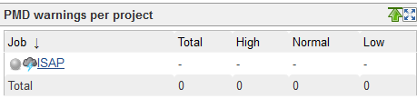

Load balancing in Jenkins can be over come by following options :
- By default Jenkins tries to allocate a jobs to the last node is was executed on.
- plugin overrides the default behavior and assigns jobs to nodes with the least load.
- Even Scheduler Plugin is used to behave with this.
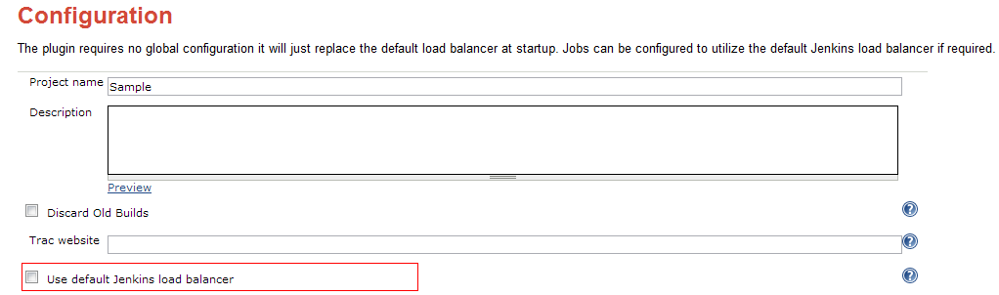
JIRA integration with Jenkins

In Application Link JIRA we will map the Jenkins appliations

Configurable Application Name and URL
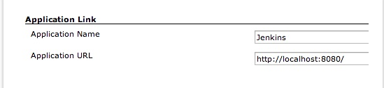

Application Links Management Page
- A new page is added to the list under Manage Jenkins
- Manage Jenkins > Application Links
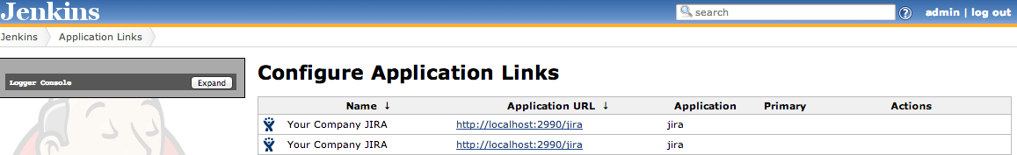

- JIRA we need to have Jenkins plugins and configuration like below
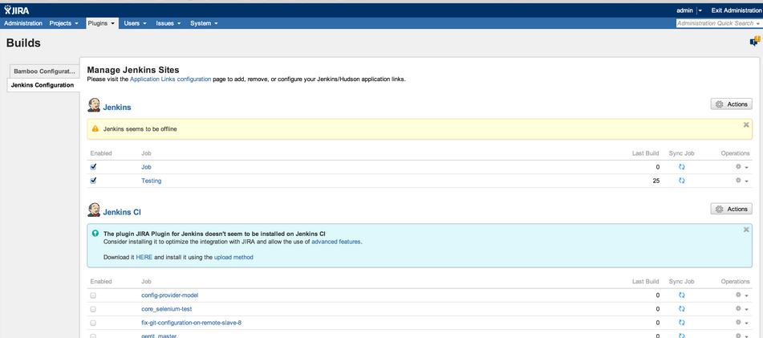

GFHOME=/apps/glassfish3/deploy
DEPLOY_PATH=/tmp/liferay_deploy

cd $DEPLOY_PATH

for f in concentra*.war; do
echo $f
cp $DEPLOY_PATH/$f $GFHOME
chmod 777 $GFHOME/$f
done

$warFileLocation="$directory\apps\src\ccm7\services\dist\services.war"
if (Test-Path "$warFileLocation")
{
Write-Host "Packaging the app executable files: $appName.$buildVer.zip"
& "D:\Tools\7zip\7za.exe" a "$directory\$appName.$buildVer.zip" "$warFileLocation"
}

Once doing deployment for tomcat server , please modify in the config tomcat file with the following lines

<tomcat-users xmlns="http://tomcat.apache.org/xml"
xmlns:xsi="http://www.w3.org/2001/XMLSchema-instance"
xsi:schemaLocation="http://tomcat.apache.org/xml tomcat-users.xsd"
version="1.0">
<user username="tomcat" password="tomcat" roles="manager-gui"/>
<user username="deployer" password="deployer" roles="manager-script" />

And in the Jenkins you need to install the corresponding plugins –
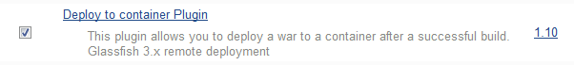
And then need to fill the details like below
